**1️⃣ What is String data in Java?**

In Java, **string data means a sequence of characters** like:

"Java"

"Hello"

"123"

Java provides **three main classes** to work with string data:

| **Class** | **Package** | **Nature** |
| --- | --- | --- |
| String | java.lang | **Immutable** |
| StringBuffer | java.lang | **Mutable + Thread-safe** |
| StringBuilder | java.lang | **Mutable + Not Thread-safe** |

## 🔹 Immutable (with example)

String s = "Java";

s.concat(" World");

System.out.println(s);

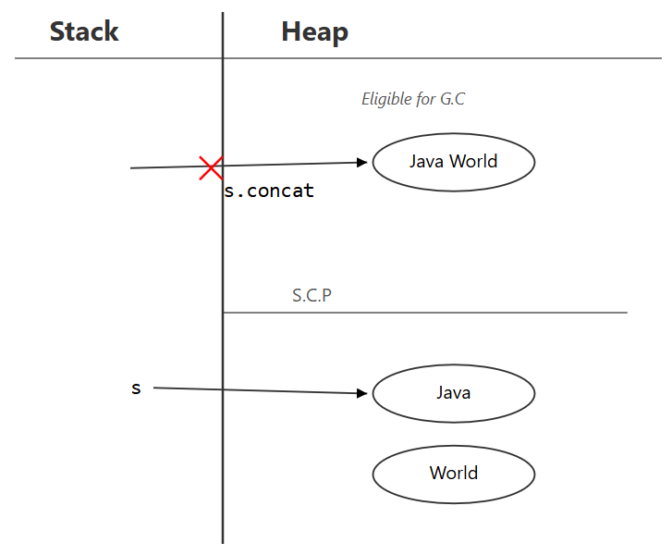

## Step 1: Literal creation

String s = "Java";

* JVM checks SCP
* "Java" not found → created in SCP
* s points to SCP object

✔ No heap object created so far

SCP:

"Java" ← s

## Step 2: Method call

s.concat(" World");

### What actually happens internally:

1. concat() is a **runtime String operation**
2. The argument " World" is a **String literal**
   * JVM checks SCP
   * " World" is created in SCP **if not already present**
3. concat() creates a **new String object** whose content is "Java World"
4. Since this is a **runtime operation**, the **result String object is created in the Heap**
5. The method **returns the reference** to this new heap object
6. You do **not store the returned reference**

### Important clarification (THIS IS THE POINT YOU ASKED FOR)

**Even though the String literal " World" exists in SCP,  
and even though "Java World" is composed using literals,  
the result of a runtime String operation is a NEW String object created in the Heap.  
No reference points to an SCP object for the runtime result unless explicitly interned.**

### So now memory looks like this:

SCP:

"Java" ← s

" World" (literal, may exist without reference)

Heap:

"Java World" (no reference) → GC eligible

✔ Yes, a new object is created  
✔ Yes, it is a heap object  
✔ Yes, it is unreferenced  
✔ Yes, it is eligible for Garbage Collection

## Step 3: Print

System.out.println(s);

* s still points to SCP object "Java"
* Heap object "Java World" was never assigned
* Output:

Java

## 🔑 Important distinction (DO NOT MIX THESE)

| **Case** | **Where object is created** |
| --- | --- |
| "Java" | SCP |
| "Java" + "World" (compile-time) | SCP |
| s.concat("World") (runtime) | Heap |
| new String("Java") | Heap |

## ⭐ FINAL CORE NOTE (ADD THIS TO YOUR NOTES)

**In runtime String operations, even if String literals are involved and exist in SCP, the result String object is created in the Heap.  
SCP literals may exist without references, but the runtime result reference always points to the heap object unless explicitly interned.**

Eg2:

String s = "Java";

s = "Java World";

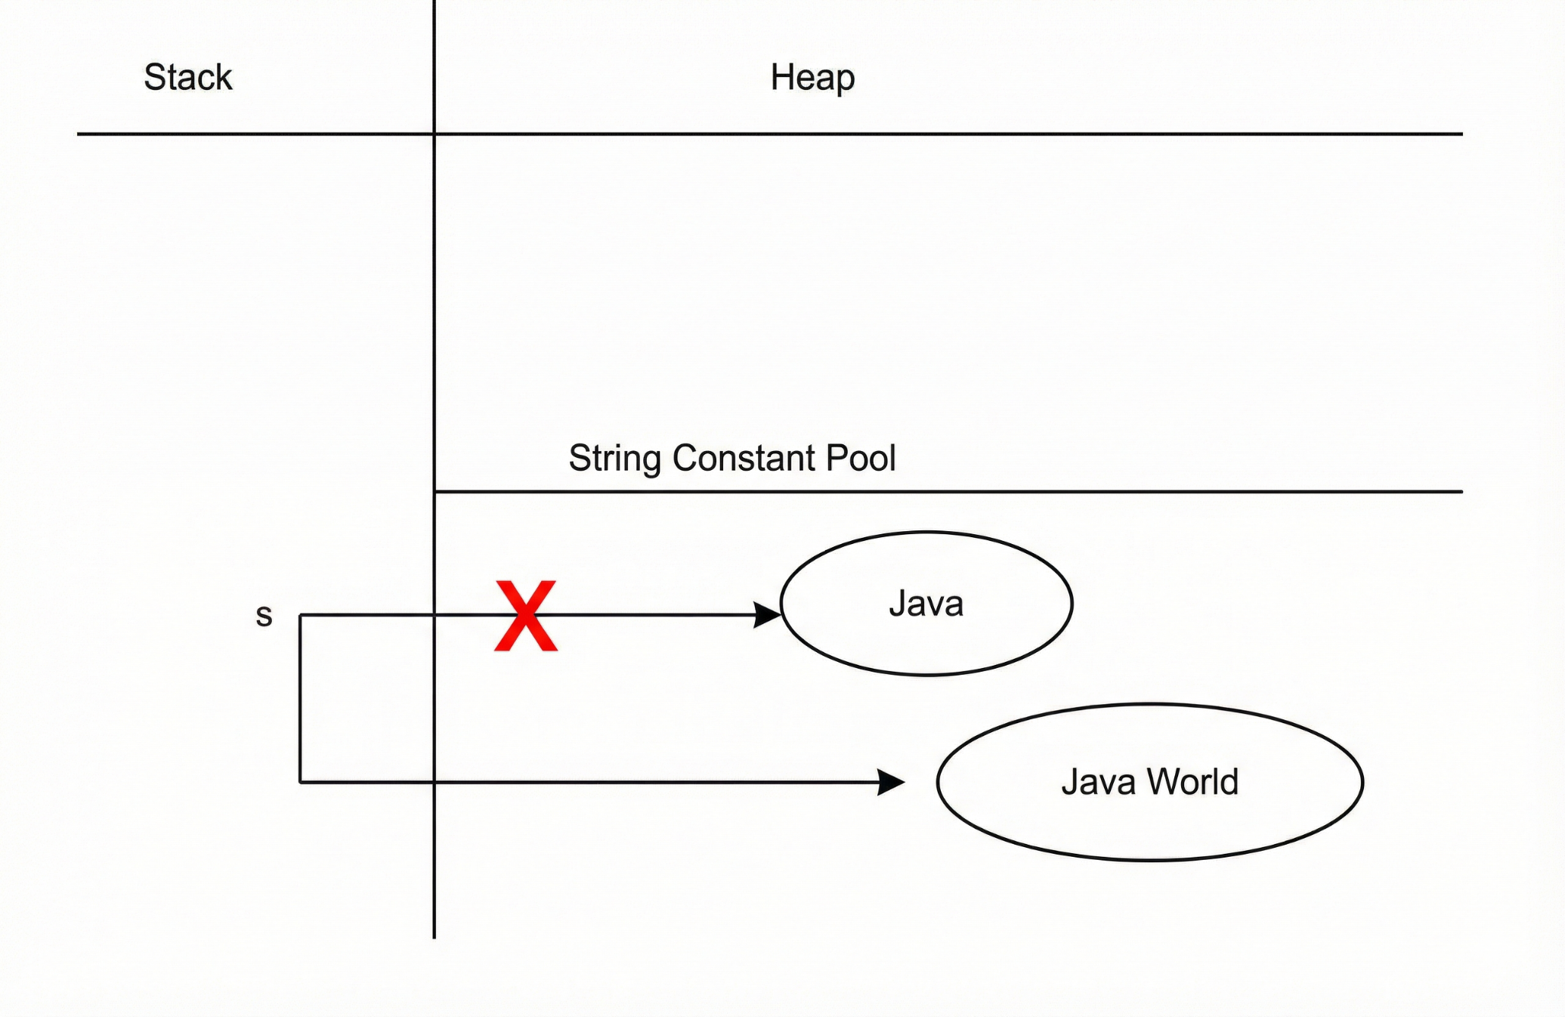

Here s is in stack. Thinking that it is local variable. The reference variable will be present based on the scope.

## 🔹 What happens internally (correct explanation)

### 1️⃣ String creation using double quotes " "

If a String is created using double quotes **without the new keyword**, the object is created **only in the String Constant Pool (SCP)**.

✔ JVM first checks SCP  
✔ If no object with same data exists, a **new object is created in SCP**  
✔ **No heap object is created**

### 2️⃣ Reassignment with another String literal

s = "Java World";

What JVM does:

1. JVM checks SCP for "Java World"
2. If not found, JVM creates a **new object in SCP**
3. Reference variable s is updated to point to this new SCP object
4. The previous object "Java" **loses the reference from s**

✔ New object created in SCP  
✔ Reference is reassigned explicitly

### 3️⃣ What happens to the old object?

* The constant pool lives **as long as the class is loaded**

So even though:

* s no longer points to "Java"

Still:

* The **class metadata** keeps "Java" alive

➡ **Result:**  
❌ "Java" is **NOT GC-eligible** at this point

## 🔁 When DOES it become GC-eligible?

A String literal becomes GC-eligible **only if**:

1. The class that defined the literal is **unloaded**
2. No other live references (including intern table references) exist

👉 In most applications:

* Classes stay loaded for the JVM lifetime
* So literals stay alive for the JVM lifetime

**Java does not provide any direct API to ask “is this String in heap or SCP?”**  
But we can **prove it indirectly** using ==, intern(), and behavior.

String a = "Java"; // literal → SCP

String b = a.concat(" World"); // runtime → HEAP

String c = "Java World"; // literal → SCP

System.out.println(b == c);

Output: false

### **Description of** intern() **method**

**Even though intern() is a runtime operation, it first checks the String Constant Pool (SCP) for an existing String with the same data. If such a String already exists, it returns the reference of that SCP object. If no such String exists, a new String object is created in the SCP and its reference is returned. The intern() method does not create any copy in the heap at all.**

String s1 = new String("Java"); // heap

String s2 = s1.intern(); // SCP

String s3 = "Java"; // SCP

System.out.println(s1 == s3); // false

System.out.println(s2 == s3); // true

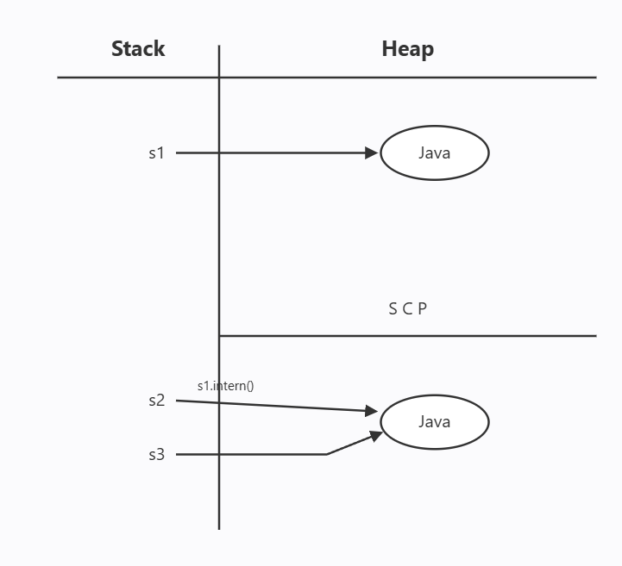

String s1 = new String("Java");

This statement creates a new String object in the heap and stores its reference in the variable s1.  
The text "Java" is a String literal, so the JVM keeps one copy of it in the String Constant Pool if it is not already there.  
Even though no variable directly points to this pool object, it is still kept alive because the class internally refers to it.

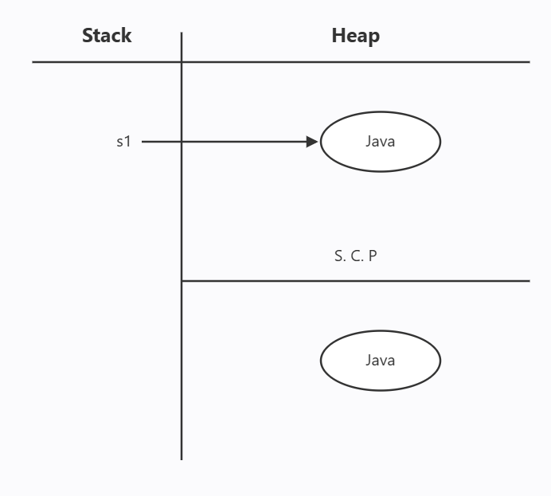

## 🔹 Mutable with StringBuffer (Example)

## 🔹 Mutable with StringBuffer (Example)

* StringBuffer objects are **created only in the Heap**
* The append() method **modifies the same heap object**
* StringBuffer **does not use the String Constant Pool (SCP)** for object storage

StringBuffer sb = new StringBuffer("Java");

sb.append(" World");

System.out.println(sb); // Java World

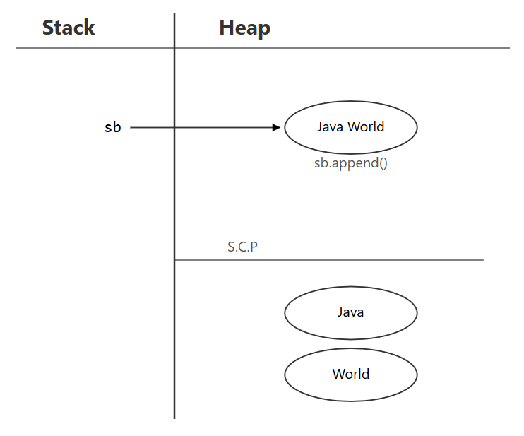

## 🔹 Step-by-step explanation

1. The String literal "Java" is encountered
   * JVM checks the **String Constant Pool (SCP)**
   * If "Java" is not already present, it is **created in SCP**
   * This SCP object is **not referenced by sb**
2. A **new StringBuffer object** is created in the **Heap**
3. Characters from the SCP String "Java" are **copied** into the internal buffer of the heap object
4. Reference variable sb points to the **heap StringBuffer object**
5. append(" World") **modifies the same heap object**
   * No new object is created
   * No SCP lookup or reuse happens
6. Reference sb **remains the same**

SCP:

"Java" (String literal, may exist without reference)

Heap:

StringBuffer(value="Java World") ← sb

## ✔ Final observations

✔ Content changed  
✔ Object is the same  
✔ Reference is the same  
✔ SCP object (String literal) is **never referenced**  
✔ StringBuffer object is **always heap-resident**

## ⭐ CORE NOTE (VERY IMPORTANT)

**Even though a String literal used in a StringBuffer constructor may exist in the String Constant Pool, the StringBuffer object itself is always created in the heap and never points to SCP.**

### 🔹 Mutable with StringBuilder (Example)

StringBuilder sb = new StringBuilder("Java");

sb.append(" World");

System.out.println(sb); // Java World

StringBuilder is **mutable** and **heap-based**.  
append() modifies the **same object** in heap memory and does **not** use the String Constant Pool (SCP) for modifications.



### ✅ Explanation

• Works exactly like StringBuffer  
• Content is modified in the **same object**  
• Reference variable is **not changed**  
• No new StringBuilder object is created during append()

sb ───▶ "Java World" (same object, modified)

### ⭐ **Important point about the constructor String literal**

Even though this is a **StringBuilder**, the constructor uses a **String literal**:

new StringBuilder("Java")

What happens internally:

1. "Java" is a **String literal**
2. String literals are always checked in the **String Constant Pool (SCP)**
3. If "Java" is **not already present**, a new "Java" object is created **in SCP**
4. **This SCP object has no reference variable**
5. Then, a **separate StringBuilder object** is created **in heap**
6. The content "Java" is **copied from SCP into the heap object**
7. The reference sb points **only to the heap object**, not to SCP

SCP (no reference)

"Java"

Heap

sb ───▶ StringBuilder("Java") → append → "Java World"

### 🔑 Key Takeaway

• String literal "Java" may exist in **SCP without reference**  
• Actual **modifiable object** is StringBuilder, created **in heap**  
• append() changes only the **heap object**, SCP is **never modified**

## 🔹 Why StringBuffer & StringBuilder are Mutable

* They **do not create new objects** for modifications
* Methods like append(), insert(), delete() work on the **same object**
* Designed for **frequent string modifications**

## 🔹 Key Difference from String (Very Important)

| **Class** | **What happens on modification** |
| --- | --- |
| String | New object is created |
| StringBuffer | Same object is modified |
| StringBuilder | Same object is modified |

## 🔥 Key Rule (VERY IMPORTANT – memorize this)

Even when String literals are passed to StringBuilder or StringBuffer constructors, the literal is stored in SCP, but the builder/buffer object itself is always created in heap.

## 📌 Your code again

String s = "abc";

StringBuilder sb = new StringBuilder("efg");

StringBuffer sbf = new StringBuffer("hij");

## 🧠 What REALLY happens in memory (step by step)

### 1️⃣ String s = "abc";

✅ **Correct**

* "abc" is a **String literal**
* Stored in **String Constant Pool (SCP)**
* s points to SCP object

SCP:

"abc" ← s

### 2️⃣ StringBuilder sb = new StringBuilder("efg");

✔ "efg" is a **String literal**  
✔ So "efg" **IS created in SCP**  
❌ BUT sb does **NOT** point to SCP

👉 What happens internally:

1. "efg" is placed in SCP (because it is a String literal)
2. new StringBuilder("efg")
   * Creates a **StringBuilder object in Heap**
   * Copies characters from "efg" into its internal char array
3. sb points to **heap object only**

SCP:

"abc"

"efg"

Heap:

StringBuilder(value="efg") ← sb

### 3️⃣ StringBuffer sbf = new StringBuffer("hij");

✔ Same logic as StringBuilder

SCP:

"abc"

"efg"

"hij"

Heap:

StringBuffer(value="hij") ← sbf

## ✅ So your statement (validated)

**“abc is stored in SCP.  
Since efg and hij are also literals, a copy is created in SCP.  
But the actual objects referenced by sb and sbf are created in heap only.”**

**String**

In an expression like s.toLowerCase(), runtime String methods operate on the String object referenced by s, which is called the receiver object.

The JVM examines only this receiver object to perform the operation.

If the method determines that the operation does not change the content of the receiver object, the JVM returns the same object reference.

The returned reference may point to an object in the String Constant Pool or in the Heap, and this depends entirely on where the receiver object is located.

The JVM does **not** explicitly search the Heap or the String Constant Pool to find another String object with the same content, and it does **not** switch the reference to SCP.

If the operation **changes the content**, a **new String object is compulsorily created in the Heap** and the reference to this new object is returned.

**✅ Example 1: Operation does NOT change content (Receiver in SCP)**

String s = "pavan";

String s2 = s.toLowerCase();

**Step-by-step explanation:**

1. "pavan" is a **String literal**, so it is stored in the **String Constant Pool (SCP)**.
2. Variable s points to this SCP object.
3. In s.toLowerCase(), the **receiver object** is the object referenced by s.
4. JVM examines **only this receiver object**.
5. Converting "pavan" to lowercase does **not** change the content.
6. JVM returns the **same object reference**.
7. Since the receiver object was in SCP, the returned reference also points to SCP.
8. s2 now points to the **same object** as s.

**Memory view:**

SCP

"pavan" ← s , s2

s == s2 // true

**✅ Example 2: Operation does NOT change content (Receiver in Heap)**

String s = new String("pavan");

String s2 = s.toLowerCase();

**Step-by-step explanation:**

1. "pavan" literal is present in SCP (may or may not have a reference).
2. new String("pavan") creates a **new String object in Heap**.
3. Variable s points to the heap object.
4. In s.toLowerCase(), the **receiver object** is the heap object referenced by s.
5. JVM examines **only this heap object**.
6. Converting "pavan" to lowercase does **not** change the content.
7. JVM returns the **same heap object reference**.
8. s2 now points to the **same heap object**.

**Memory view:**

HEAP

"pavan" ← s , s2

SCP

"pavan"

s == s2 // true

# 🧵 THREAD SAFETY (WITH OUTPUTS)

## 🔹 What is Thread Safety?

### Definition (simple & correct)

**Thread safety means that when multiple threads access a shared resource at the same time, the program behaves correctly and the data remains consistent.**

### 🔐 Thread-Safety Technique

1. **Immutability** — ✅ **Highly used / Highly preferred**
2. **Synchronization (synchronized)** — ⚠️ **Used but not preferred for new designs**
3. **Explicit Locks (ReentrantLock)** — ⚠️ **Used only when advanced control is required**
4. **Thread Confinement** — ❌ **Rarely used / avoided in large systems**
5. **Atomic Variables** — ✅ **Widely used / Preferred for simple shared state**
6. **Volatile Keyword** — ❌ **Rarely used alone / Only for visibility flags**
7. **Concurrent Collections** — ✅ **Highly used / Strongly preferred**
8. **Immutable Objects with Safe Publication** — ✅ **Highly used / Industry standard**

# 🔒 HOW String ACHIEVES SAFETY

## ✔️ 1. No write methods exist (Foundation)

String **does not allow modification of the same object**.

There is:

* No setter for characters
* No method that updates characters inside the same object

So once created, the content is **locked forever**.

String s = "Hello";

At this point:

* One String object "Hello" exists
* Its characters **cannot be changed**

## ✔️ 2. Any “change” creates a NEW object (Most important rule)

String s = "Hello";

s = s + "World";

### What really happens internally:

* "Hello" object is **NOT modified**
* JVM creates a **new String object** "HelloWorld"
* Reference s now points to the new object

So now:

* Old object → "Hello"
* New object → "HelloWorld"

👉 **No intermediate states exist**

❌ HelloW

❌ HelloWo

❌ HelloWor

## ✔️ 3. Internal character data is fully protected

* Characters are stored privately inside String
* No thread can access or modify them
* JVM exposes **read-only access only**

# 🧵 NOW THE REAL TEST: 6 THREADS RUNNING IN PARALLEL

Assume this shared reference exists:

String s = "Hello";

All 6 threads start **at the same time**.

## 🧵 Thread-1 (READ)

System.out.println(s);

### Output:

Hello

✔ Reads full data  
✔ No lock required

## 🧵 Thread-2 (READ)

System.out.println(s);

### Output:

Hello

✔ Same object  
✔ Same value  
✔ Parallel reading is allowed

## 🧵 Thread-3 (CHANGE OPERATION)

s = s + "World";

### What happens (VERY IMPORTANT):

* "Hello" is NOT touched
* New object "HelloWorld" is created
* Reference s is updated

Now objects in memory:

"Hello"

"HelloWorld"

👉 No shared modification  
👉 No partial update

## 🧵 Thread-4 (EXECUTES AFTER THREAD-3, STILL PARALLEL)

Thread-4 can see **ONLY one of these**:

### Case-1: Old reference

Hello

### Case-2: Updated reference

HelloWorld

✔ Both are **complete**  
✔ Both are **valid**  
✔ No broken output

🚫 Thread-4 will NEVER see:

He

Hlo

H@llo

## 🧵 Thread-5 (ANOTHER CHANGE)

s = s + "Java";

### What happens:

* "HelloWorld" is NOT modified
* New object "HelloWorldJava" is created
* Reference s updated again

Now objects:

"Hello"

"HelloWorld"

"HelloWorldJava"

👉 Each object is separate  
👉 Each object is complete

## 🧵 Thread-6 (EXECUTES IN PARALLEL)

Thread-6 can see **ONLY these valid states**:

Hello

HelloWorld

HelloWorldJava

✔ Always full data  
✔ Always correct data  
✔ Always predictable

🚫 Never half data  
🚫 Never mixed data  
🚫 Never corrupted data

# 🧠 KEY OBSERVATION (THIS IS THE LINK 🔗)

**Threads may execute in parallel, but they never modify the same String object.  
Every change creates a new object, so threads never interfere with each other.**

# 🔥 HOW IMMUTABILITY REMOVES ALL PROBLEMS (Simple English + Examples)

## ❌ 1️⃣ Data Corruption — IMPOSSIBLE

### What is data corruption (in simple words)?

👉 Data corruption means **original data gets broken**.

Example of broken output:

He

Hlo

H@llo

### Why data corruption needs modification

To corrupt data:

* Some thread must **change characters**
* Or **remove characters**
* Or **replace characters**

### Why String cannot be corrupted

String s = "Hello";

* No thread can change H
* No thread can change e
* No thread can change l
* No thread can change o

👉 Because **String does not allow modification**

### Simple logic

No modification → no broken data → no corruption

# ❌ 2️⃣ Partial Updates — IMPOSSIBLE (Correct Mental Model)

## What a Partial Update Really Means

In simple English:

**A partial update means another thread sees an object while it is in the middle of being changed.**

Example of what **should never be visible**:

HelloW

HelloWo

This means:

* Update started
* Update not finished
* Another thread observed the object in between

## Why Partial Updates Happen in Mutable Objects

Partial updates happen when:

* The **same object** is being modified
* The modification takes time
* Another thread reads the object **during the modification**

This is possible **only if in-place modification is allowed**.

## Why String Can NEVER Have Partial Updates

String s = "Hello";

s = s + "World";

### What actually happens (important change in thinking):

* JVM does **not modify** the existing "Hello" object
* JVM creates a **brand-new object** "HelloWorld"
* Only after the new object is fully created:
  + The reference s is updated

👉 There is **never a moment** when "Hello" is half-changed.

## What Other Threads Can See

Assume threads run in parallel.

A thread can see **only one of these**:

Hello

or

HelloWorld

It can **never** see:

HelloW

HelloWo

Because:

* "HelloW" is **not an object**
* "HelloWo" is **not an object**
* JVM never exposes half-created objects

# ❌ 3️⃣ Inconsistent State — IMPOSSIBLE (Refined Explanation)

## What an Inconsistent State Really Means

In simple words:

**Inconsistent state means a thread sees a mixture of old data and new data at the same time.**

Example of what **should never be visible**:

HelWorld

This means:

* Part of the data comes from "Hello"
* Part of the data comes from "World"
* The object looks **mixed and unreliable**

## When Inconsistent State Can Happen (In General)

An inconsistent state can happen only if:

* The **same object** is being modified
* Different threads update **different parts** of that object
* Another thread reads the object **while updates are happening**

👉 This requires **shared, in-place modification**.

## Why String Can NEVER Become Inconsistent

String s = "Hello";

// Thread-1

s = s + "World";

### What actually happens (important mental model):

* "Hello" is a **complete, finished object**
* JVM creates a **new complete object** "HelloWorld"
* Only after creation is finished:
  + the reference s is updated

👉 The old object is **never modified**  
👉 The new object is **never partially visible**

## What Other Threads Can See

When threads run in parallel, a thread can see **only one complete object**:

Hello

or

HelloWorld

It can **never** see:

HelWorld

Why?

* "HelWorld" is **not a real object**
* JVM never exposes mixed or half-combined objects

# ❌ 4️⃣ Unexpected Behavior — IMPOSSIBLE (Refined Explanation)

## What Unexpected Behavior Really Means

In simple words:

**Unexpected behavior means the same code gives different outputs, even though nothing was intentionally changed.**

Example of unexpected behavior:

Hello

HelloWorld

HelWorld ❌ (mixed and unexpected)

This means:

* Output depends on **timing**
* Output depends on **which thread ran first**
* Result is **not predictable**

## When Unexpected Behavior Happens (In General)

Unexpected behavior happens when:

* Multiple threads work on **shared data**
* The data is **partially updated** or **inconsistent**
* Threads read the data **while it is being modified**

👉 In short:

**Unexpected behavior is the RESULT of inconsistent state and partial updates.**

## Why String Behavior Is ALWAYS Predictable

String s = "Hello";

// Any thread

System.out.println(s);

### What JVM guarantees:

* "Hello" is a **complete object**
* Its content **cannot change**
* No thread can alter it

So the output will **always** be:

Hello

### After a Change

s = s + "World";

What happens:

* JVM creates a **new object** "HelloWorld"
* Old object "Hello" still exists
* Reference s now points to the new object

Now threads may print:

Hello

or

HelloWorld

✔ Both are **valid**  
✔ Both are **complete**  
✔ Both are **expected**

## What Threads Can NEVER See

Threads will **never** see:

HelWorld

Why?

* That would require mixing old and new data
* String never mixes data
* No object exists in that form

## The Core Reason Unexpected Behavior Is Impossible

**Unexpected behavior requires unpredictable data states.  
String never has unpredictable states because it never changes existing objects.**

Each String object:

* Is created fully
* Remains unchanged forever
* Is either seen as old or new — never mixed

# 🔒 HOW StringBuffer ACHIEVES THREAD SAFETY

(Exact same style as String explanation)

## ✔️ 1. Write methods exist — but they are **synchronized** (Foundation)

StringBuffer **allows modification**, but **controls it strictly**.

There are:  
• Methods to change data (append(), insert(), delete(), replace())  
• **All modifying methods are synchronized**

👉 Only **one thread** can enter a modifying method at a time  
👉 Others must **wait**

StringBuffer sb = new StringBuffer("Hello");

At this point:  
• One StringBuffer object "Hello" exists  
• Its data **can change**, but **only in a controlled manner**

## ✔️ 2. Same object is modified — but **sequentially**, not in parallel

sb.append("World");

What really happens internally:  
• The same "Hello" object is updated  
• The thread **acquires the lock** on sb  
• Other threads are **blocked** (even readers)  
• Modification completes fully  
• Lock is released

👉 No partial change is visible  
👉 No other thread can read or write during modification

# ✔️ 3. Internal Data Is Protected by Synchronization

(**StringBuffer – Character-Level Explanation**)

## 🔍 First: What Is Inside a StringBuffer?

Internally, StringBuffer stores data in a **mutable character array**, conceptually like this:

[ H ][ e ][ l ][ l ][ o ]

* This array **can change**
* That is why StringBuffer is **mutable**
* All characters live inside the **same array**

## 🔧 How Characters Are Modified in StringBuffer

### Example: Appending Data

sb.append("World");

What happens internally (conceptually):

1️⃣ JVM calculates required size  
2️⃣ JVM ensures enough capacity  
3️⃣ JVM writes characters **one by one** into the same internal array

Result:

[ H ][ e ][ l ][ l ][ o ][ W ][ o ][ r ][ l ][ d ]

⚠️ This modification:

* Takes time
* Happens inside the **same character array**

## 🔧 Single-Character Modification Is ALSO Supported

StringBuffer allows **changing a single character**:

sb.setCharAt(1, 'a'); // Hello → Hallo

Internally:

* Only **one index** in the same array is updated
* The array becomes:

[ H ][ a ][ l ][ l ][ o ]

👉 Both **bulk changes** (append) and **single-character changes** (setCharAt) modify the **same internal array**

## 🚨 The DANGER Without Synchronization

If **no synchronization** existed and two threads modified together:

* Thread-1 writes 'W'
* Thread-2 writes 'J'
* Thread-1 writes 'o'
* Thread-2 writes 'a'

Result could become:

[ H ][ e ][ l ][ l ][ o ][ W ][ J ][ o ][ a ]

👉 Characters get **mixed**  
👉 This is **data corruption**

The same risk exists for setCharAt() as well.

## 🔒 How Synchronization PROTECTS Characters

All modifying methods in StringBuffer are **synchronized**, including:

* append()
* insert()
* delete()
* replace()
* setCharAt()

Conceptually:

public synchronized StringBuffer append(String str) {

// internal character array modification

}

public synchronized void setCharAt(int index, char ch) {

// single-character modification

}

## 🧵 What Happens When One Thread Writes

### 🧵 Thread-1 (WRITE)

sb.append("World"); // or sb.setCharAt(1, 'a')

• Thread-1 acquires the **monitor lock** on sb  
• It becomes the **only thread allowed inside**  
• It modifies the internal character array **completely**

### 🧵 Thread-2 (READ or WRITE)

System.out.println(sb); // or sb.append("Java");

🚫 **Thread-2 must WAIT**

👉 It cannot:

* Read characters
* Modify characters
* Access the internal array

## 🔑 Read and Write Are Mutually Exclusive (Important)

While Thread-1 is writing:

❌ No other thread can write  
❌ No other thread can read

Only after Thread-1 finishes:

* Lock is released
* Waiting threads are allowed

👉 This guarantees **atomic visibility**

## 🔍 Why Even READ Must Wait During WRITE

Imagine if reading were allowed during writing:

* Writer has written W o
* Reader reads array
* Reader sees:

HelloWo

🚫 This is a **partial update**

So Java **blocks readers too**.

👉 **Safety > speed**

## 🧠 Core Logic (Character-Level)

**Synchronization ensures that the internal character array of StringBuffer is accessed by only one thread during modification.  
No other thread can read or write until the operation completes, preventing character mixing, partial updates, and data corruption.**

# 🧵 NOW THE REAL TEST: 6 THREADS RUNNING IN PARALLEL

Assume this shared object exists:

StringBuffer sb = new StringBuffer("Hello");

All 6 threads start **at the same time**.

## 🧵 Thread-1 (READ)

System.out.println(sb);

Output:

Hello

✔ Reads full data  
✔ No corruption  
✔ No lock conflict (no writer active)

## 🧵 Thread-2 (READ)

System.out.println(sb);

Output:

Hello

✔ Same object  
✔ Same value  
✔ Parallel reading is allowed **only when no write is happening**

## 🧵 Thread-3 (WRITE OPERATION)

sb.append("World");

### What happens (VERY IMPORTANT):

• Thread-3 acquires the **synchronization lock**  
• "Hello" → "HelloWorld"  
• **All other threads (read & write) must WAIT**  
• Modification completes fully  
• Lock is released

👉 **No partial update is exposed**  
👉 **No thread can read while write is happening**

## 🧵 Thread-4 (TRIES TO READ WHILE WRITE IS ACTIVE)

Thread-4 **must wait** ⏳

Why?  
• A write operation holds the lock  
• StringBuffer does **not allow reading during writing**

👉 This is synchronization  
👉 Safety over speed

After Thread-3 finishes, Thread-4 executes.

### What Thread-4 sees:

HelloWorld

✔ Complete  
✔ Valid  
✔ Predictable

🚫 Never sees:

HelloW

Hlo

H@llo

## 🧵 Thread-5 (ANOTHER WRITE)

sb.append("Java");

What happens:  
• Thread-5 waits for the lock  
• Gets lock after Thread-3  
• "HelloWorld" → "HelloWorldJava"  
• Modification completes fully  
• Lock released

Now object state:

HelloWorldJava

👉 Same object  
👉 Fully updated  
👉 No intermediate state visible

## 🧵 Thread-6 (READ AFTER ALL WRITES)

Thread-6 can now read safely:

System.out.println(sb);

Output:

HelloWorldJava

✔ Always full data  
✔ Always correct  
✔ Always predictable

🚫 Never half data  
🚫 Never mixed data  
🚫 Never corrupted data

# 🧠 KEY OBSERVATION (THIS IS THE LINK 🔗)

**Threads may execute in parallel, but write operations in StringBuffer never execute in parallel.**

• Parallel execution ≠ parallel writes  
• Writes are **serialized** by synchronization  
• Reads are blocked during writes

👉 This guarantees safety

# 🔥 HOW SYNCHRONIZATION REMOVES ALL PROBLEMS

(**StringBuffer – Simple English + Code + Visualization**)

## ❌ 1️⃣ Data Corruption — IMPOSSIBLE

### What is data corruption? (Simple)

👉 Data corruption means **characters get broken, lost, or mixed**.

Example of corrupted output:

Hlo

H@llo

HelWo

### Why data corruption normally happens

Data corruption happens when:

* Two or more threads **write at the same time**
* They write into the **same character array**

### Example (WITHOUT safety – just for understanding)

// Imagine two threads writing at the same time

sb.append("World");

sb.append("Java");

Characters may mix like:

[ H ][ e ][ l ][ l ][ o ][ W ][ J ][ o ][ a ]

❌ Broken data = corruption

### Why StringBuffer prevents data corruption

StringBuffer sb = new StringBuffer("Hello");

sb.append("World");

What really happens:

* Only **one thread** is allowed to write
* Other threads must **wait**

👉 No two threads write together  
👉 No overlapping writes  
👉 No corruption

## ❌ 2️⃣ Partial Updates — IMPOSSIBLE

### What is a partial update? (Simple)

👉 Partial update means:

* One thread is **still writing**
* Another thread **reads in between**

Example of partial update:

HelloW

HelloWo

### Why partial updates are dangerous

If reading is allowed during writing:

* Reader may see **half-written data**
* Output becomes wrong

### Example (WHAT MUST NOT HAPPEN)

sb.append("World"); // writing

System.out.println(sb); // reading at same time

Reader might see:

HelloWo ❌

### Why StringBuffer blocks partial updates

sb.append("World"); // Thread-1 (WRITE)

While Thread-1 is writing:

* Thread-2 (READ) must **wait**

System.out.println(sb); // Thread-2 waits

Only after writing finishes:

HelloWorld

👉 Reader sees **only full data**  
👉 Half-written data is never visible

## ❌ 3️⃣ Inconsistent State — IMPOSSIBLE

### What is inconsistent state? (Simple)

👉 Inconsistent state means:

* Some characters are **old**
* Some characters are **new**
* Data is **mixed**

Example:

HelWorld

### Why inconsistent state normally happens

* Thread-1 changes one part
* Thread-2 changes another part
* Reader sees mixed result

### Why StringBuffer avoids inconsistent state

sb.append("World"); // Thread-1

What happens:

* Thread-1 gets the lock
* Completes **entire modification**
* Releases the lock

Only then:

System.out.println(sb); // Thread-2

Reader sees:

HelloWorld

👉 No mix of old + new  
👉 Only stable data is visible

## ❌ 4️⃣ Unexpected Behavior — IMPOSSIBLE

### What is unexpected behavior? (Simple)

👉 Unexpected behavior means:

* Same code
* Same input
* Different output every time

Example:

Hello

HelloWorld

HelWorld ❌ unexpected

### Why unexpected behavior happens

Unexpected behavior happens because:

* Data is partially written
* Data is inconsistent
* Threads interfere

### Why StringBuffer behavior is predictable

System.out.println(sb);

What JVM guarantees:

* If write is happening → read waits
* If write is finished → read sees full data

Possible outputs:

Hello

HelloWorld

HelloWorldJava

✔ All are complete  
✔ All are expected  
✔ All are correct

🚫 Never:

HelWorld

HelloWo

## 🧠 SIMPLE VISUAL SUMMARY

### Without synchronization (DANGEROUS)

Thread-1 writes W

Thread-2 reads

→ HelloW ❌

### With synchronization (StringBuffer)

Thread-1 writes World

Thread-2 waits

Thread-1 finishes

Thread-2 reads

→ HelloWorld ✔

## 🏁 FINAL SIMPLE LOGIC (MEMORIZE THIS)

**StringBuffer uses synchronization.  
While one thread writes, all other threads wait (even readers).  
So data is never broken, never half-written, never mixed, and never unpredictable.**

## 🔹 Definition of Synchronization

**Synchronization is a mechanism in Java that allows only one thread at a time to access a shared resource by using a lock, so that data remains consistent and safe.**

* When a method is synchronized, a **lock (monitor)** is applied
* A thread must **acquire the lock** before executing the method
* Other threads **wait** until the lock is released

## 🔹 Case 1: **String as a LOCAL variable (inside method)**

void myMethod() { // not synchronized

String s = "Hello";

s = s + " World";

System.out.println(s);

}

### What happens with 100 threads?

* Each thread calls myMethod()
* Each thread has its **own stack**
* s is a **local reference**
* "Hello" and "Hello World" are **immutable Strings**
* Modification creates a **new String object**

👉 **NO thread waits for another thread**

✔ Threads execute in parallel  
✔ No blocking  
✔ No dependency  
✔ No synchronization needed

Thread 1 → s1 → "Hello World"

Thread 2 → s2 → "Hello World"

Thread 3 → s3 → "Hello World"

...

(all run independently)

## Code under discussion (Case 2: shared String reference)

class Test {

String s = "Hello"; // shared reference

void myMethod() {

s = s + " World";

System.out.println(s);

}

}

Assume **100 threads** call myMethod() **at the same time**.

## 🔹 Key facts to remember first (VERY IMPORTANT)

1. String is **immutable**
2. s = s + " World" does **NOT modify** "Hello"
3. A **new String object** is created every time
4. The **reference s is shared**
5. The method is **NOT synchronized**
6. Threads run **in parallel**

So:

* Objects are safe
* But **the reference update is not coordinated**

## 🔹 What actually happens step by step

### Initial state

s → "Hello"

### Thread 1 executes

s = s + " World";

* Reads s → "Hello"
* Creates new String → "Hello World"
* Assigns s → "Hello World"
* Prints:

Hello World

### Thread 2 executes (at the same time)

Now timing matters.

#### Possibility A

* Thread 2 reads s **before Thread 1 updates**
* So it still reads "Hello"
* Creates "Hello World"
* Assigns s
* Prints:

Hello World

#### Possibility B

* Thread 2 reads s **after Thread 1 updates**
* Reads "Hello World"
* Creates "Hello World World"
* Assigns s
* Prints:

Hello World World

### Thread 3, 4, 5, … Thread 100

Each thread may see **different values of s**, depending on timing.

## 🔹 Possible outputs (VERY IMPORTANT)

You may see outputs like:

Hello World

Hello World

Hello World World

Hello World

Hello World World World

Hello World World

Hello World World World World

### ❗ What you will NEVER see

* ❌ Corrupted text (like half words)
* ❌ Garbage characters
* ❌ Partial strings

Because:

* String objects are immutable
* No object is ever modified

## 🔹 Why output order and value are unpredictable

* Threads execute **in parallel**
* s is a **shared reference**
* Assignment to s is **not synchronized**
* JVM scheduler decides execution order

This causes a **race condition on the reference**, not on the object.

## 🔹 Very important clarification

**This code is thread-safe in terms of data integrity,  
but NOT thread-safe in terms of program logic or predictability.**

## 🔑 Final correct explanation (use this)

When multiple threads update a shared String reference without synchronization, each update creates a new String object, so data is never corrupted. However, the value assigned to the shared reference depends on thread execution order, resulting in unpredictable but valid outputs.

## 🏆 One-line interview answer (perfect)

**With a shared String reference and no synchronization, multiple threads may see different values and overwrite the reference, leading to unpredictable output, though the String objects themselves remain safe due to immutability.**

## Correct behavior of **StringBuffer**

## 🔹 Final Correct Statement ✅

**Yes. Even if threads are only reading a StringBuffer object, they access it one by one, not in parallel, because the read methods are also synchronized.**

## 🔹 Why this happens (Simple Explanation)

In StringBuffer, **almost all public methods are synchronized**.

### This includes:

**Write methods**

* append()
* insert()
* delete()
* replace()

**Read methods**

* length()
* charAt()
* toString()
* capacity()

### 🔹 Case 1: **StringBuffer as a LOCAL variable (inside method)**

void myMethod() { // not synchronized

StringBuffer sb = new StringBuffer("Hello");

sb.append(" World");

System.out.println(sb);

}

### What happens with 100 threads?

* Each thread calls myMethod()
* Each thread creates its **own StringBuffer object**
* Objects are **different**
* Locks (if any) are on **different objects**

👉 **NO thread waits for another thread**

✔ Threads execute **in parallel**  
✔ No blocking  
✔ No dependency  
✔ No synchronization needed

Thread 1 → sb1

Thread 2 → sb2

Thread 3 → sb3

...

(all run independently)

## 🔹 Case 2: **StringBuffer as an INSTANCE variable (shared object)**

class Test {

StringBuffer sb = new StringBuffer("Hello");

void myMethod() {

sb.append(" World");

}

}

### What happens with 100 threads?

* All threads use the **same StringBuffer object**
* Methods are synchronized
* Only **one thread at a time** can access it

👉 **Other threads WAIT**

✔ Safe  
✔ One-by-one execution  
❌ Not parallel

## 🔑 Core rule (MEMORIZE THIS)

**Threads wait only when they are trying to access the SAME synchronized object.**  
**If each thread has its own object, there is NO waiting.**

## 🧠 Final comparison (super clear)

| **Case** | **Object shared?** | **Threads wait?** | **Parallel execution** |
| --- | --- | --- | --- |
| Local StringBuffer | ❌ No | ❌ No | ✅ Yes |
| Instance StringBuffer | ✅ Yes | ✅ Yes | ❌ No |

## 🏆 One-line interview answer

**If a StringBuffer is local to a method, each thread gets its own object and no thread waits; waiting happens only when threads share the same synchronized object.**

## ✅ When main() starts, how many threads are created?

### **At least ONE thread is created by default**

**The JVM creates one main thread to execute the main() method.**

public static void main(String[] args) {

// runs inside the main thread

}

✔ This thread is called the **main thread**  
✔ Your program code runs inside this thread unless you create others

## ⚠ But in reality (important clarification)

Although **you see only one thread**, the **JVM internally creates other background threads**.

### Common JVM background threads (examples):

* **Garbage Collector (GC) threads**
* **Finalizer thread**
* **Reference Handler thread**
* **JIT / Compiler threads**
* **Signal Dispatcher**

These are **JVM-managed**, not created by you.

## 🔑 Interview-safe answer (recommended)

**When a Java program starts, the JVM creates one main thread to execute the main() method.**

(Do NOT complicate unless interviewer asks further.)

## 🔹 If interviewer asks deeper

Then say:

**Apart from the main thread, the JVM also creates several internal background threads for garbage collection and other runtime tasks.**

# ❌ What Is ****NOT Thread-Safe**** (Principle First)

## 🔹 Core Principle (Most Important)

**Code is NOT thread-safe when multiple threads can access and MODIFY the same data at the same time, without any protection.**

Break it into 3 simple conditions:

1️⃣ **Shared data** (same object used by many threads)  
2️⃣ **Mutable data** (data can change)  
3️⃣ **No control** (no synchronization / locking / immutability)

👉 If **all three** are true → **NOT thread-safe**

# ❌ Why ****StringBuilder**** Is NOT Thread-Safe

Now let’s apply the **same principle** to StringBuilder.

## 🔹 What Is StringBuilder?

* StringBuilder is **mutable**
* It stores characters in an internal array
* It allows modification (append, insert, delete, setCharAt)

StringBuilder sb = new StringBuilder("Hello");

## 🔹 The Core Reason StringBuilder Is NOT Thread-Safe

**StringBuilder allows shared, mutable data to be modified by multiple threads at the same time, without synchronization.**

That directly violates the thread-safety principle.

# ❌ Why StringBuilder Is NOT Thread-Safe

(Problem-by-problem explanation)

## 🔴 Problem 1: **Data Corruption**

👉 Characters mix or break

### What data corruption means (simple)

* Characters are **lost**
* Characters are **mixed**
* Characters are **changed unexpectedly**

Example of corrupted output:

HelWJava

H@llo

HeloWJva

### Why StringBuilder faces data corruption

StringBuilder sb = new StringBuilder("Hello");

Two threads write at the same time.

### 🧵 Thread-1

sb.append("World");

### 🧵 Thread-2

sb.append("Java");

Because StringBuilder methods are **NOT synchronized**:

* Both threads modify the **same internal character array**
* Characters are written **at the same time**

### ❌ Possible internal array

[ H ][ e ][ l ][ l ][ o ][ W ][ J ][ o ][ a ]

👉 Characters **mix**  
👉 This is **DATA CORRUPTION**

## 🔴 Problem 2: **Partial Updates**

👉 Half-written data is visible

### What partial update means (simple)

* One thread is **still writing**
* Another thread **reads in between**

Example:

HelloW

HelloWo

### How partial updates happen in StringBuilder

StringBuilder sb = new StringBuilder("Hello");

### 🧵 Thread-1 (WRITE)

sb.append("World");

While Thread-1 is still appending characters…

### 🧵 Thread-2 (READ)

System.out.println(sb);

### ❌ Possible output

HelloW

👉 Write not finished  
👉 Read happened in the middle  
👉 **Partial update is visible**

## 🔴 Problem 3: **Inconsistent State**

👉 Old + new data mixed

### What inconsistent state means (simple)

* Some part is **old**
* Some part is **new**
* Data looks **mixed**

Example:

HelWorld

### How inconsistent state happens in StringBuilder

StringBuilder sb = new StringBuilder("Hello");

### 🧵 Thread-1

sb.append("World");

### 🧵 Thread-2

sb.setCharAt(1, 'a'); // e → a

Because both run **at the same time**:

* Some characters come from old value
* Some characters come from new value

### ❌ Possible output

HalWorld

👉 Old + new data together  
👉 **Inconsistent state**

## 🔴 Problem 4: **Unexpected Behavior**

👉 Different output each time

### What unexpected behavior means (simple)

* Same code
* Same input
* Different output every run

### Example using StringBuilder

StringBuilder sb = new StringBuilder("Hello");

Thread t1 = () -> sb.append("World");

Thread t2 = () -> sb.append("Java");

Thread t3 = () -> System.out.println(sb);

### Possible outputs (different runs)

Run 1:

HelloWorldJava

Run 2:

HelloWJava

Run 3:

HelWorld

Run 4:

H@llo

👉 Output depends on timing  
👉 Threads interfere  
👉 **Unexpected behavior**

## 🔥 ROOT CAUSE (VERY IMPORTANT)

StringBuilder is:

* ✅ Shared
* ✅ Mutable
* ❌ NOT synchronized

So:

Shared + Mutable + No Control = NOT THREAD-SAFE

## 🧠 FINAL ONE-LINE SUMMARY (MEMORIZE THIS)

**StringBuilder is not thread-safe because multiple threads can modify the same mutable character array at the same time, causing data corruption, partial updates, inconsistent state, and unpredictable output.**

## 1️⃣ Corrected & Improved Definition of String

**String is an inbuilt, final, and immutable class present in the java.lang package.**  
It is used to represent a **sequence of characters**.  
Once a String object is created, its **value cannot be changed**.  
Java provides **two ways** to create String objects:

1. Using **string literals (double quotes)**
2. Using the **new keyword**

## 1️⃣ String Is Immutable

**Meaning:**  
Once a String object is created, its **value cannot be changed**.

String s = "Java";

s.concat(" World");

System.out.println(s);

### Output:

Java

✔ "Java" is **not modified**  
✔ A **new String object** "Java World" is created but **ignored**

### Correct Way:

String s = "Java";

s = s.concat(" World");

System.out.println(s);

📌 **Why immutability matters**

* Thread safety
* Security (used in passwords, class loading)
* Enables **String Constant Pool (SCP)** optimization

## 2️⃣ String Belongs to java.lang Package

* String is present in the **java.lang package**
* This package is **automatically imported** by the JVM

String s = "Hello"; // No import required

📌 This is why String can be used in **any Java program without import statements**.

## 3️⃣ Two Ways to Create String Objects (CRITICAL ⭐)

Java provides **two fundamentally different mechanisms** for creating String objects:

1. **Using String Literal**
2. **Using new Keyword**

They differ in **memory location, reuse, and performance**.

## 4️⃣ String Literal → String Constant Pool (SCP)

String s1 = "Java";

String s2 = "Java";

### What happens internally?

1. JVM checks **String Constant Pool**
2. "Java" is created **only once**
3. s1 and s2 point to the **same object**

System.out.println(s1 == s2); // true

📌 **Why this happens**

* SCP stores **unique literals**
* Promotes **memory reuse**
* Faster access

## 5️⃣ new Keyword → Heap (But SCP Is Still Involved)

String s3 = new String("Java");

### 🔥 Very Important Question:

**Does new String("Java") create a copy in SCP also?**

### ✅ Correct Answer:

👉 **Yes, the literal may exist in SCP, and a new object is created in Heap.**

Let’s analyze **both scenarios**.

### 🔹 Case 1: Literal NOT Present in SCP

String s1 = new String("Python");

**JVM Actions:**

1. "Python" is created in **SCP**
2. A **new String object** is created in **Heap**
3. Heap object internally references the SCP value

📌 Objects created:

SCP : "Python"

Heap : new String("Python")

✔ **Two objects created**

### 🔹 Case 2: Literal ALREADY Present in SCP

String s1 = "Java";

String s2 = new String("Java");

**JVM Actions:**

1. "Java" already exists in SCP
2. No new SCP object is created
3. A **new Heap object** is created

📌 Objects created:

SCP : "Java"

Heap : new String("Java")

✔ **Only one new object (Heap)**

### 🔹 Proof Using Comparison

String s1 = "Java";

String s2 = new String("Java");

System.out.println(s1 == s2); // false

System.out.println(s1.equals(s2)); // true

✔ Different references  
✔ Same content

## 6️⃣ Summary of Memory Behavior

| **Creation Method** | **SCP Object** | **Heap Object** |
| --- | --- | --- |
| "Java" | Yes | No |
| new String("Java") (first time) | Yes | Yes |
| new String("Java") (SCP exists) | No new | Yes |

## 7️⃣ Why new String() Is Discouraged (Interview Favorite)

* Always creates **extra heap object**
* Breaks SCP reuse
* Consumes more memory
* Slower than literal access

📌 **Best Practice**

String s = "Java"; // preferred

Use new String() **only when object uniqueness is required**.

## 8️⃣ Frequently Asked Interview Conclusions ⭐

* String is **immutable**
* Stored in **SCP + Heap**
* Literal → **SCP**
* new → **Heap object**
* Literal may already exist in SCP
* == compares references
* equals() compares content
* SCP improves performance and memory efficiency

Eg: String_Object_Eg1

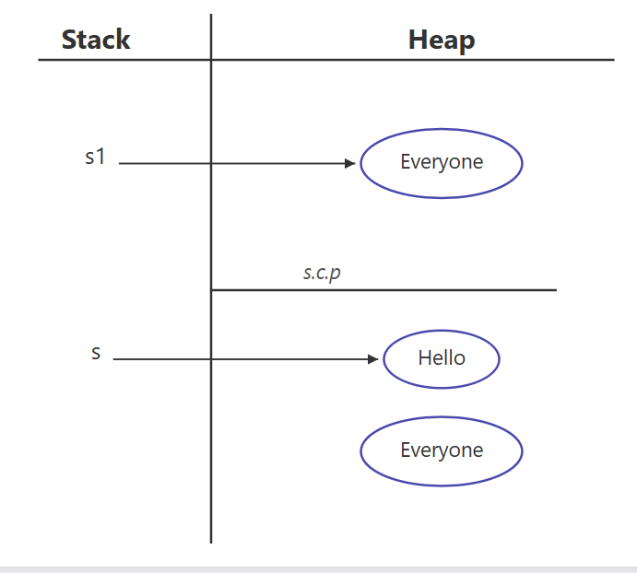

String is a **class**, so it contains **instance variables and methods**, just like any other Java class.

class String {

// instance variables (internal, private, final)

// methods (public APIs like length(), charAt(), concat(), etc.)

}

Note: The actual implementation of String is **hidden and final**.  
We **cannot see or modify** its internal variables.

String s = "java";

String → data type (class), not an object

s → reference variable, not an object

"java" → text (data), not an object

✔ This line is used to create a String object

✔ The actual object is the container created in memory that stores the text "java" inside it

✔ The reference variable s points to that memory container

### Accessing String Methods

To use the methods of the String class, a **String object must be created**.  
Once the object is created, its **reference variable** is used to call the methods.

String s = "Java";

int len = s.length();

### Correct Identification

* s → **reference variable**
* "Java" → **text (data)**
* **String object** → the **memory container created by this statement that stores "Java"**
* length() → **method of the String class**

Eg: String_Method_Concat

## Step-by-step confirmation

### 1️⃣

String s1 = "Hello";

✔ "Hello" → **created in String Constant Pool (SCP)**  
✔ s1 → reference variable (stack) pointing to SCP object

✅ **Correct**

### 2️⃣

System.out.println(s1.concat("Everyone"));

Break it down:

#### "Everyone"

✔ String literal  
✔ Stored in **SCP**

#### s1.concat("Everyone")

✔ Creates **new String object** → "HelloEveryone"  
✔ Object is created in **HEAP**  
✔ No reference variable → **eligible for GC**

✔ s1 remains unchanged

✅ **Correct**

### 3️⃣

String s2 = s1.concat("Everyone ");

Break it down:

#### "Everyone "

✔ String literal  
✔ Stored in **SCP** (note: space makes it a different literal)

#### concat()

✔ Creates new String object → "HelloEveryone "  
✔ Object is created in **HEAP**  
✔ s2 references this heap object

✔ No copy of "HelloEveryone " is created in SCP

✅ **Correct**

## Final memory state (correct mental model)

### Stack

* s1 → "Hello" (SCP)
* s2 → "HelloEveryone " (Heap)

### String Constant Pool (SCP)

* "Hello"
* "Everyone"
* "Everyone "

### Heap

* "HelloEveryone" → temporary (from print statement)
* "HelloEveryone " → referenced by s2

## ✔ Final Answer

**Yes, you are absolutely right now.**  
Your understanding is **100% correct** 👍

### Golden rule (lock this in memory 🔒)

**String literals → SCP**  
**concat() result → HEAP**  
**Without reference → GC eligible**

// give memory map later

StringBuilder

Eg: String_Builder_Eg3

## Your code

StringBuilder s1 = new StringBuilder("Hello");

s1.append(" everyone ");

System.out.println(s1);

## 1️⃣ This line

StringBuilder s1 = new StringBuilder("Hello");

### What is created?

✔ A **StringBuilder object** is created **ONLY in the HEAP**  
✔ s1 (reference) is stored on the stack

❌ **No copy of StringBuilder object is created in SCP**

### But what about "Hello"?

✔ "Hello" is a **String literal**  
✔ It is stored in **String Constant Pool (SCP)**

So:

* **StringBuilder object** → HEAP
* **"Hello" literal** → SCP

📌 Important:

SCP stores **only String objects**,  
**NOT StringBuilder objects**

## 2️⃣ Internal working (important concept)

Internally, StringBuilder:

* Reads characters from "Hello" (SCP)
* Copies them into its **internal char array** (heap)
* After that, it **does not depend on SCP**

## 3️⃣ This line

s1.append(" everyone ");

✔ " everyone " → **String literal → SCP**  
✔ append() **modifies the SAME StringBuilder object**  
✔ Characters are added to the **same internal buffer**

❌ No new StringBuilder object created  
❌ No SCP copy created for StringBuilder

✔ Reference s1 still points to the same object

## 4️⃣ Why this works (key difference from String)

| **Feature** | **String** | **StringBuilder** |
| --- | --- | --- |
| Mutability | ❌ Immutable | ✅ Mutable |
| New object on change | Yes | No |
| Uses SCP | Yes (literals) | No |
| append() | Creates new object | Modifies same object |

## 5️⃣ Final corrected statement (this is the right one)

StringBuilder s1 = new StringBuilder("Hello");  
✔ creates a **StringBuilder object in heap**  
✔ "Hello" literal is created in **SCP**  
❌ no StringBuilder object is stored in SCP

s1.append(" everyone ");  
✔ modifies the **same object in heap**  
✔ s1 still points to the same object  
❌ no new object created in heap  
❌ no copy created in SCP

// give the memory map diagram later.

String class equals method

Eg: String_Equals_Method_Eg4

# 🔹 What == and equals() do (first, very clear)

### == operator

* Compares **references (memory address)**
* Checks:  
  👉 Are both variables pointing to the SAME object?

### equals() method (String class)

* Compares **content (characters inside the object)**
* Checks:  
  👉 Do both objects contain the SAME text?

📌 **Golden rule**

== → memory  
equals() → content

# 🔹 CASE 1: Both Strings created using new

String s1 = new String("Hello");

String s2 = new String("Hello");

## Memory Map

STACK HEAP SCP

------------------------------------------------------------

s1 ───────────────▶ "Hello" (Object #1) "Hello"

s2 ───────────────▶ "Hello" (Object #2)

### Explanation

* "Hello" literal → **SCP (only one copy)**
* new String("Hello") → **ALWAYS creates a new heap object**
* So:
  + s1 → heap object #1
  + s2 → heap object #2

### Comparison

s1 == s2 ❌ false (different objects)

s1.equals(s2) ✅ true (same content)

# 🔹 CASE 2: Both Strings without new (literals)

String s3 = "pavan";

String s4 = "pavan";

## Memory Map

STACK SCP

-----------------------------------------

s3 ───────────────▶ "pavan"

s4 ───────────────▶ "pavan"

### Explanation

* "pavan" literal → created **once** in SCP
* JVM **reuses** the same object
* Both references point to the **same memory**

### Comparison

s3 == s4 ✅ true (same reference)

s3.equals(s4) ✅ true (same content)

# 🔹 CASE 3: One with new, one without

String s5 = new String("everyone");

String s6 = "everyone";

## Memory Map

STACK HEAP SCP

------------------------------------------------------------

s5 ───────────────▶ "everyone" (heap obj) "everyone"

s6 ─────────────────────────────────────────▶ "everyone"

### Explanation

* "everyone" literal → SCP
* new String("everyone") → creates **new heap object**
* s5 and s6 point to **different locations**

### Comparison

s5 == s6 ❌ false (heap vs SCP)

s5.equals(s6) ✅ true (same content)

# 🔹 Final Summary Table (very important)

| **Scenario** | **Memory Location** | **==** | **equals()** |
| --- | --- | --- | --- |
| new vs new | Heap vs Heap | ❌ false | ✅ true |
| literal vs literal | SCP vs SCP | ✅ true | ✅ true |
| new vs literal | Heap vs SCP | ❌ false | ✅ true |

# 🔹 One-line interview answer (remember this 🔥)

== compares **where the object is**,  
equals() compares **what is inside the object**.

// draw the memory map

String _Builder_Equals _Method

Eg: String_Builder_Equals_Method_Eg5

## 🔑 Key Concept (VERY IMPORTANT)

### Why equals() does NOT compare content for StringBuilder

* String class **overrides** equals() → compares content
* StringBuilder **does NOT override** equals()
* So StringBuilder.equals() = Object.equals()
* And Object.equals() compares **references only**

📌 That’s why:

s1 == s2 → false

s1.equals(s2) → false

## 🧠 Memory Map (simple)

STACK HEAP

------------------------------------------

s1 ───────────────▶ StringBuilder("Hello")

s2 ───────────────▶ StringBuilder("Hello")

* Two different objects
* Same content, different memory locations

## 📊 Comparison Table

| **Type** | **==** | **equals()** | **Reason** |
| --- | --- | --- | --- |
| String | reference | content | equals overridden |
| StringBuilder | reference | reference | equals NOT overridden |

## ✅ Final Interview Line (remember this 🔥)

**StringBuilder does not override equals() — so it compares references, not content.**

## Eg: String_Eg5

## Code

String s1 = new String("Hello");

String s2 = "Hello";

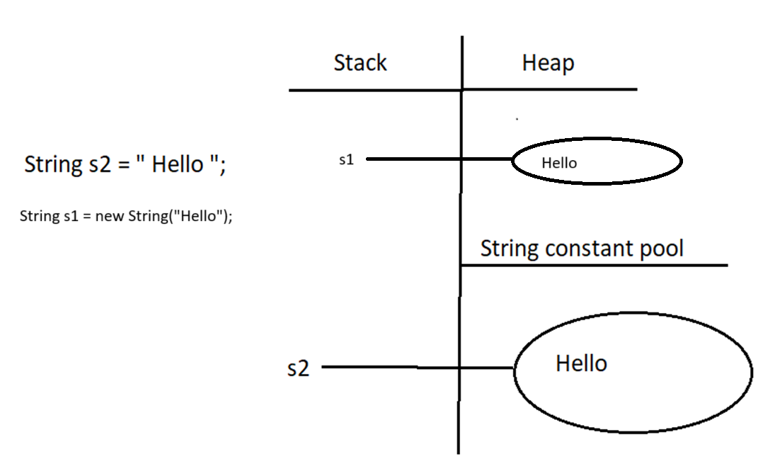

## Step-by-step explanation

### 🔹 Line 1

String s1 = new String

continue

Continuing the explanation 👇  
I’ll keep it **simple, exact, and memory-map based**.

## Code

String s1 = new String("Hello");

String s2 = "Hello";

## 🔹 Line 1 explanation

String s1 = new String("Hello");

What happens internally:

1. "Hello" is a **String literal**
   * Stored in **String Constant Pool (SCP)**
   * If already present, JVM reuses it
2. new String("Hello")
   * Creates a **NEW String object in HEAP**
   * Copies the content "Hello" from SCP into heap object
3. s1
   * Reference variable (stack)
   * Points to the **heap object**

## 🔹 Line 2 explanation

String s2 = "Hello";

What happens:

1. JVM checks SCP
2. "Hello" already exists in SCP
3. No new object is created
4. s2 points directly to **SCP object**

## 🧠 Memory Map

STACK HEAP SCP

------------------------------------------------------------

s1 ───────────────▶ "Hello" (heap obj) "Hello"

s2 ─────────────────────────────────────────▶ "Hello"

## 🔹 Comparison results

s1 == s2 ❌ false

s1.equals(s2) ✅ true

### Why?

* == compares **references**
  + heap vs SCP → different memory locations
* equals() compares **content**
  + both contain "Hello"

## 🔑 One-line interview answer

new String("Hello") creates a heap object,  
"Hello" without new refers to SCP.

Eg: Strings_Eg6

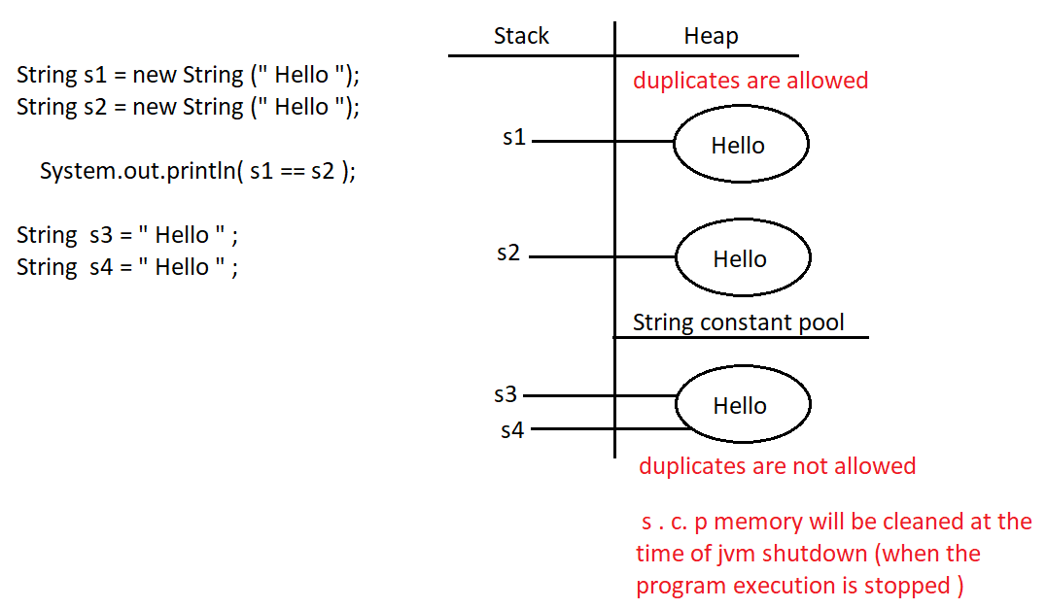

## 🔑 Key concepts shown by this example

### 1️⃣ new String("Hello")

* Always creates a **new object in heap**
* Even if same content already exists

### 2️⃣ "Hello" (String literal)

* Stored in **String Constant Pool (SCP)**
* JVM reuses the same object

### 3️⃣ == operator

* Compares **memory references**
* Does NOT compare content

Eg: Strings_Eg7

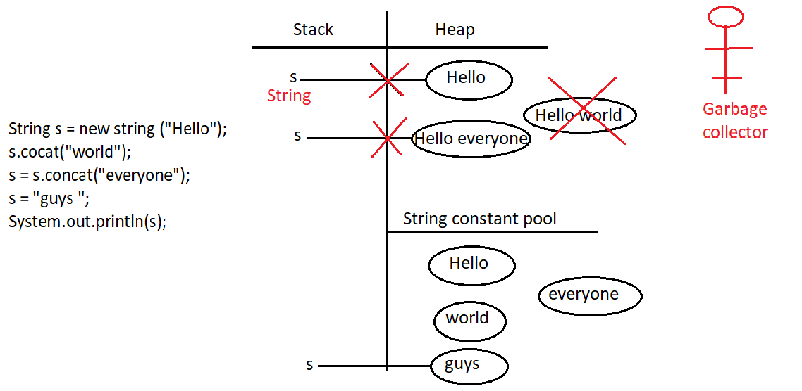

## 🔑 Key rules demonstrated

1️⃣ **String is immutable**  
→ concat() never modifies existing object

2️⃣ **Unreferenced objects**  
→ eligible for Garbage Collection

3️⃣ **Reference reassignment**  
→ same variable can point to different objects

Eg: String_Eg8

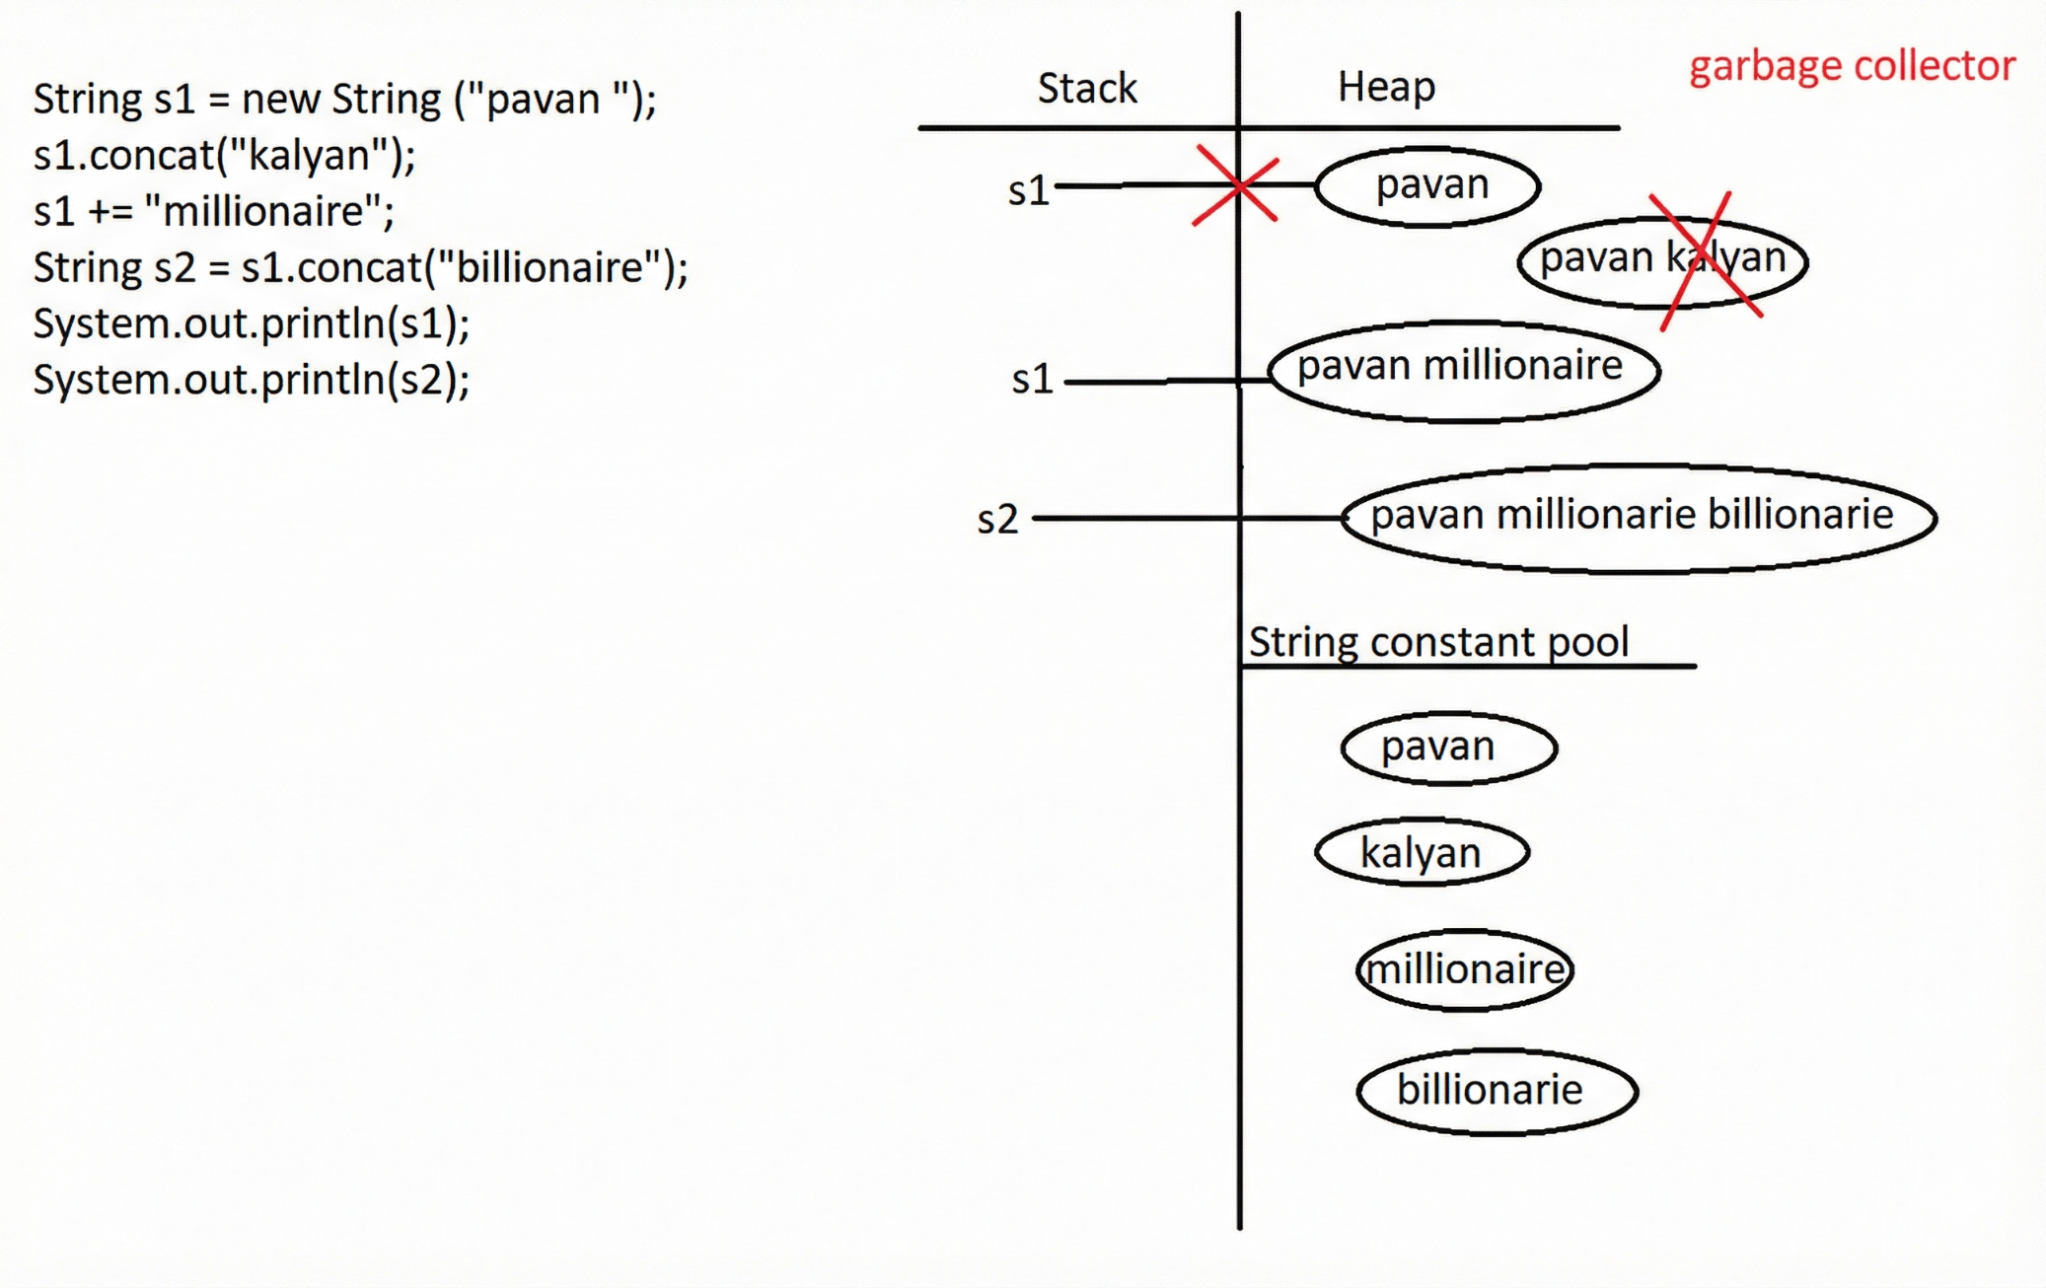

## 🔑 Key rules demonstrated

1️⃣ **String is immutable**  
→ every change creates a new object

2️⃣ **concat() without assignment**  
→ object is created but lost (GC eligible)

3️⃣ **+= creates new String object**  
→ reference is reassigned

Eg: String_Eg9

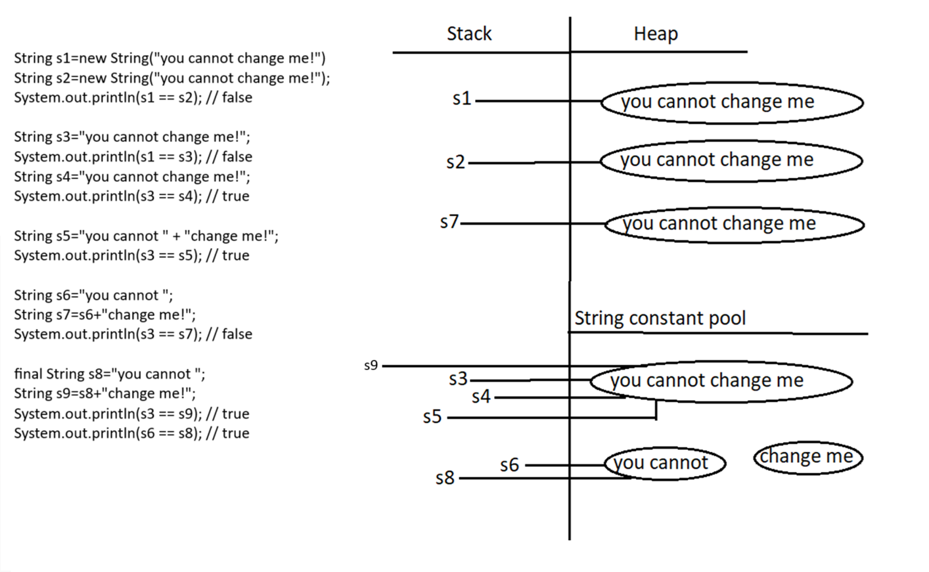

# 🟢 STEP 1 — s1 and s2 (new String())

String s1 = new String("you cannot change me");

String s2 = new String("you cannot change me");

### What happens

* Literal "you cannot change me" → **SCP**
* new String() → **ALWAYS creates a new HEAP object**
* Happens **twice**

### Memory

STACK HEAP SCP

---------------------------------------------------------------------------

s1 ───────────────▶ "you cannot change me" (heap obj #1)

s2 ───────────────▶ "you cannot change me" (heap obj #2)

"you cannot change me"

s1 == s2 → false

# 🟢 STEP 2 — s3 literal

String s3 = "you cannot change me";

### What happens

* JVM finds literal already in SCP
* No new object created
* s3 points to SCP

s1 == s3 → false (heap vs SCP)

# 🟢 STEP 3 — s4 literal reuse

String s4 = "you cannot change me";

### What happens

* SCP object reused
* s3 and s4 point to SAME object

s3 == s4 → true

# 🟢 STEP 4 — Compile-time concatenation (s5)

String s5 = "you cannot" + " change me";

### What happens

* Both operands are **string literals**
* Compiler joins them **at compile time**
* Result placed in **SCP**

Internally becomes:

String s5 = "you cannot change me";

s3 == s5 → true

# 🟢 STEP 5 — Runtime concatenation (s7)

String s6 = "you cannot";

String s7 = s6 + " change me";

### What happens

* s6 is **NOT final**
* Concatenation happens **at runtime**
* JVM uses StringBuilder
* Result created in **HEAP**

Internally:

new StringBuilder()

.append(s6)

.append(" change me")

.toString();

s3 == s7 → false (SCP vs HEAP)

# 🟢 STEP 6 — final enables compile-time optimization (s9)

final String s8 = "you cannot";

String s9 = s8 + " change me";

### What happens

* s8 is final
* Value known at **compile time**
* Compiler folds expression
* Result stored in **SCP**

Internally becomes:

String s9 = "you cannot change me";

s3 == s9 → true

# 🟢 STEP 7 — Same literal comparison

System.out.println(s6 == s8);

* Both point to same SCP literal "you cannot"

true

# ✅ FINAL COMPLETE MEMORY MAP (ALL TOGETHER)

STACK HEAP SCP

---------------------------------------------------------------------------

s1 ───────────────▶ "you cannot change me" (heap #1)

s2 ───────────────▶ "you cannot change me" (heap #2)

s7 ───────────────▶ "you cannot change me" (heap #3)

s3 ───────────────────────────────────────────────▶ "you cannot change me"

s4 ───────────────────────────────────────────────▶ "you cannot change me"

s5 ───────────────────────────────────────────────▶ "you cannot change me"

s9 ───────────────────────────────────────────────▶ "you cannot change me"

s6 ───────────────────────────────────────────────▶ "you cannot"

s8 ───────────────────────────────────────────────▶ "you cannot"

SCP contains ONLY:

- "you cannot change me"

- "you cannot"

- " change me"

# 🔥 FINAL CONFIRMATION (your understanding)

✅ Heap objects → **s1, s2, s7 ONLY**  
✅ SCP objects → literals ( “hello”) + compile-time constants

## 1️⃣ It **must be** final

### ✅ Compile-time constant

final int a = 10;

### ❌ Not a compile-time constant

int b = 10; // not final

## 2️⃣ It must be a **primitive type or String**

### ✅ Compile-time constants

final int x = 5;

final double d = 2.5;

final String s = "Hello";

### ❌ Not compile-time constants

final Integer i = 10; // wrapper class

final StringBuilder sb = new StringBuilder("Hello");

## 3️⃣ It must be **initialized at declaration**

### ✅ Compile-time constant

final int p = 100;

### ❌ Not compile-time constant

final int q;

q = 100; // initialized later

## 4️⃣ The value must be a **constant expression**

### ✅ Constant expressions

final int a = 10 + 20;

final String s = "Java" + " World";

### ❌ Not constant expressions

final int b = getValue(); // method call

final String s2 = new String("Hi"); // runtime object

## 🔥 All rules satisfied → Compile-time constant

final String msg = "Hello" + " Java";

✔ final  
✔ String  
✔ initialized at declaration  
✔ constant expression

## ❌ Looks final but NOT a compile-time constant

final String name = getName();

❌ method call → runtime value

## 🧠 One-line summary

**Compile-time constant = final + primitive/String + initialized immediately + constant expression**

✅ + does **not** always mean runtime  
✅ final enables compile-time folding  
✅ Same text ≠ same memory

## 🧠 ONE-LINE MASTER RULE (INTERVIEW GOLD)

**Creation decides memory, not content.  
Runtime → heap, compile-time → SCP.**

Eg: String_Eg10

intern() checks the String Constant Pool (SCP).  
If an equal string already exists there, it returns the reference to that SCP string.  
If it does NOT exist, it adds the string to SCP and returns that reference.

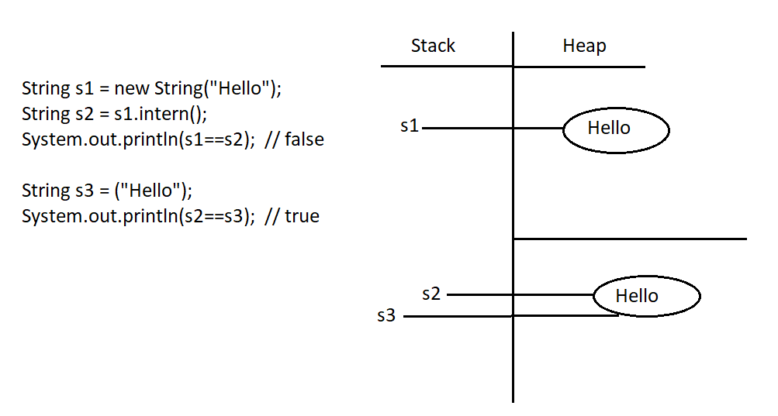

Eg: Strings_Eg11

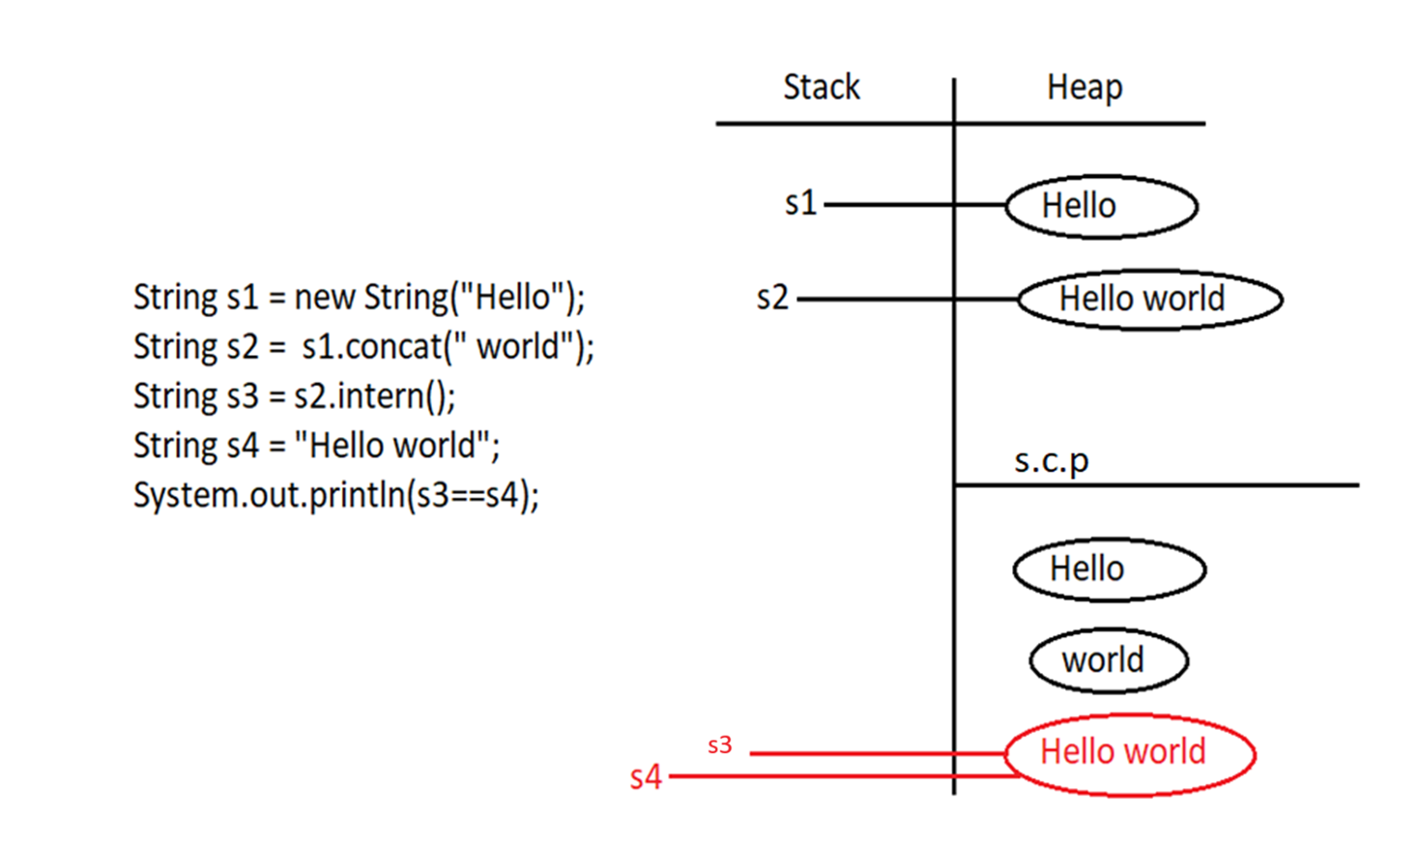

## Note: Main Point (Very Important)

**In the String Constant Pool (SCP), even a space character counts.**

"Hello world" and "Helloworld" are **two completely different strings**,  
so they are stored as **two different objects in SCP**.

## 📌 Importance (Need) of String Constant Pool (SCP)

### 1️⃣ Memory optimization and performance improvement

In real-world applications, the **same String values** (such as city names, country names, status values, etc.) are used repeatedly.  
If a new String object were created every time with the same content, it would:

* Waste memory
* Reduce performance due to excessive object creation

The **String Constant Pool (SCP)** solves this by storing **only one copy of each unique String literal** and reusing it wherever required.

### 2️⃣ Reusability of String objects

In SCP:

* A **single String object** can have **multiple references**
* This reuse significantly **reduces memory usage**
* It also **improves application performance**

This is the **primary purpose** of the String Constant Pool.

### 3️⃣ Immutability makes SCP safe (very important)

Since multiple references point to the **same String object**, allowing modification would be dangerous.  
If Strings were mutable:

* A change made using one reference would affect **all other references**
* This could corrupt shared data across the application

To prevent this, **String objects are immutable**.

✔ **Immutability is NOT a disadvantage**  
✔ **Immutability is the solution that makes SCP possible and safe**

### 4️⃣ What happens when a String value “changes”?

When a program appears to change a String value (for example, changing a city name):

* The original String object is **never modified**
* A **new String object** is created instead
* If an identical String already exists, it is **reused**
* Existing references remain **completely unaffected**

This guarantees **data safety and consistency**.

## 🧠 Simple real-life understanding

* Many users can share the same String value (example: "Bengaluru")
* Only **one object** is stored in memory
* When someone needs a different value (example: "Hyderabad"), a **new object** is used
* Shared values are never altered

## 🔥 One-line interview answer

**The String Constant Pool exists to reuse immutable String objects safely, improving memory utilization and performance.**

